Call Forwarding to cell phones

Overview: This document describes how to set call forwarding from the ILS/AE office phones to cell phones.

Starting Call Forwarding

Step 1: From your terminal server session, open Internet Explorer and copy/paste the following URL into the address field at the top of you browser:

http://192.168.32.3/Web/Common/HomePage.do
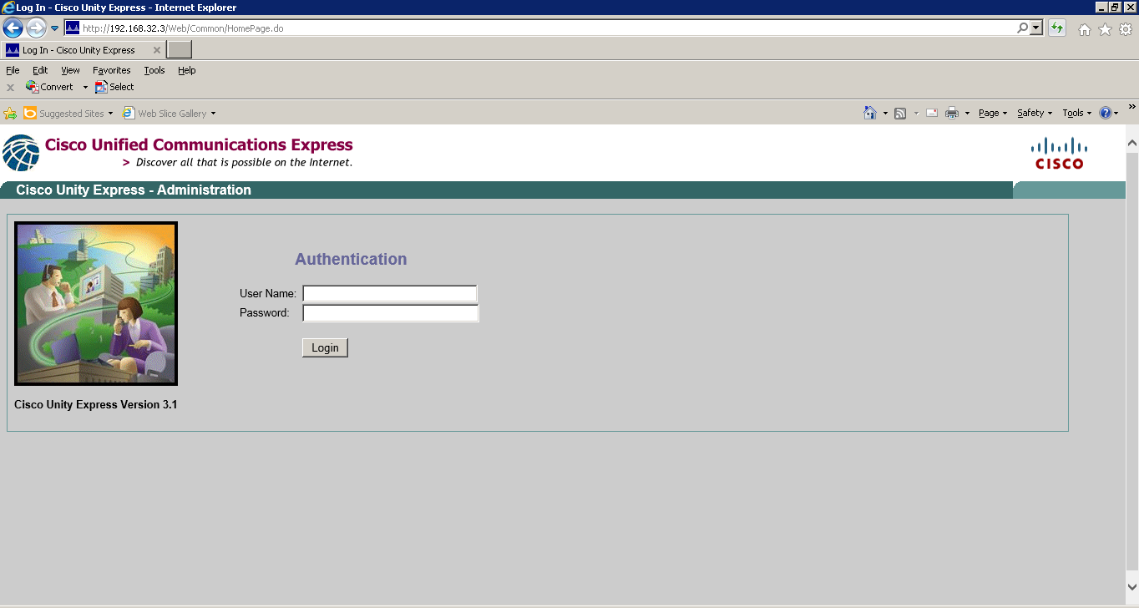
Step 2: The Cisco login website will appear. Use the credentials provided by the IT Department to login.


Step 3: Once you are logged in, click on Configure in the menu at the top.
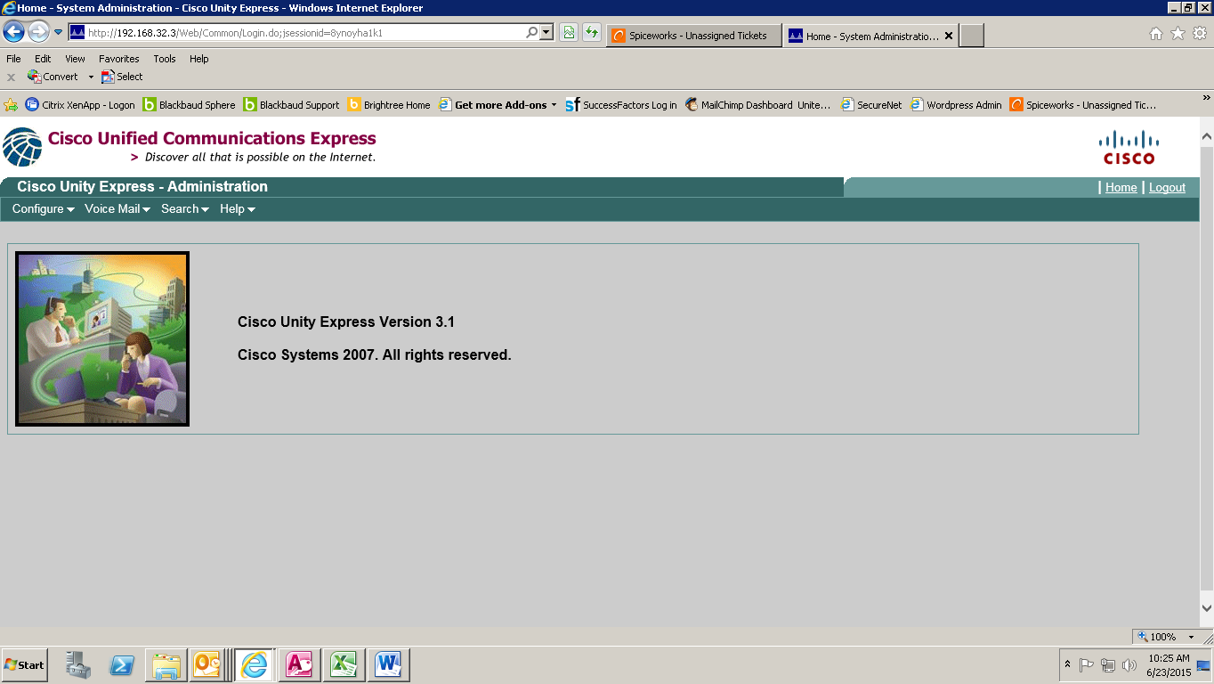
Step 4: Select Phone from the menu that appears.
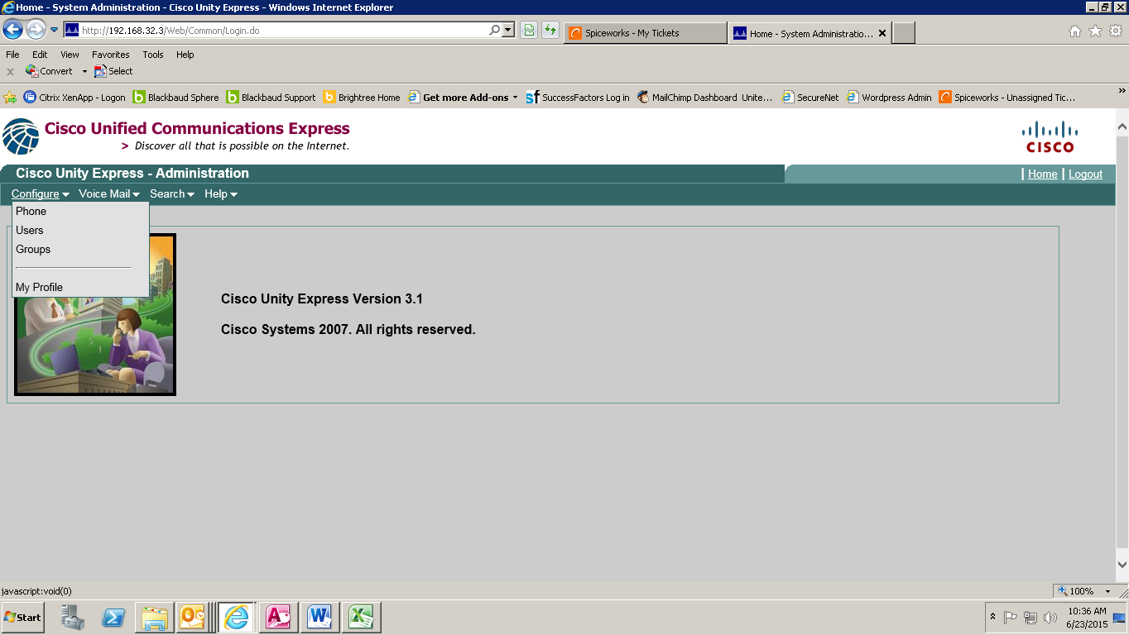

Step 5: On the next screen, click on the “Line 1” link.
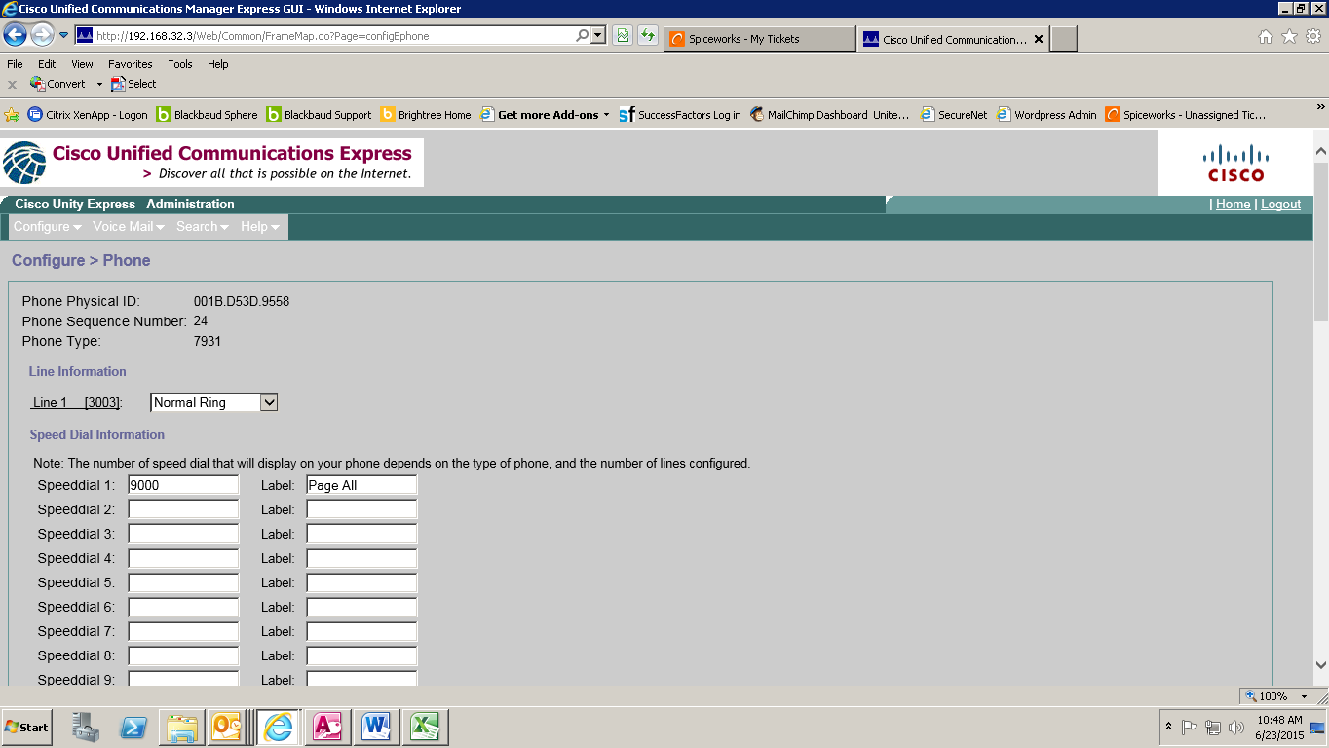
Step 6: A configuration window will pop up. In the field labeled “all”, enter the number (9 + phone number without spaces) to which you would like your calls forwarded. Click the Change button to save your changes. The configuration window will disappear.
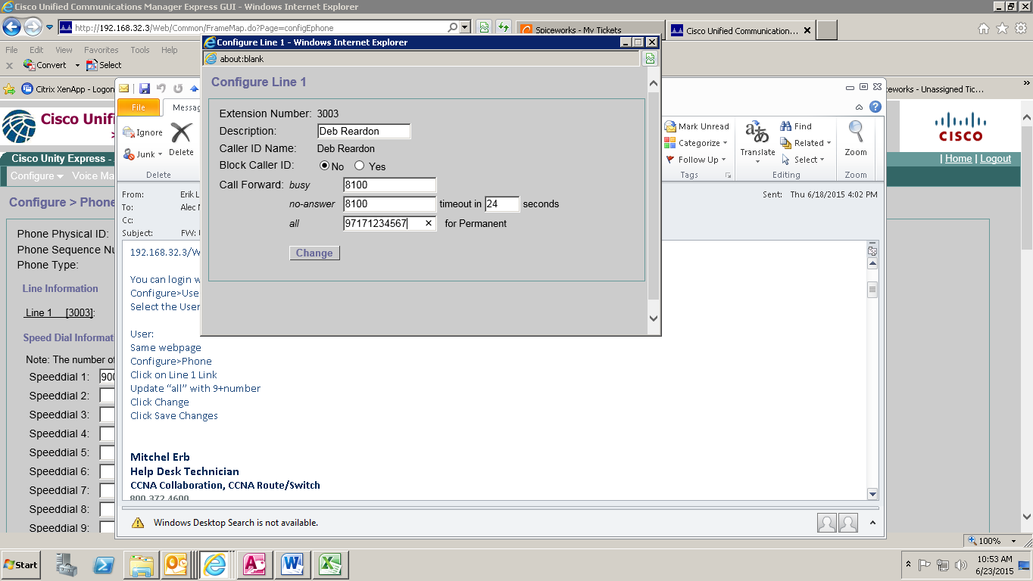

Step 7: Click Logout in the top right corner of the screen.


Stopping Call Forwarding

When you are ready to stop call forwarding, repeat steps 1 – 5 above to bring up the configuration screen, then clear the “all” field of any numbers. You can also click once in the field, then click the “x” that appears on the right side of the field to clear the contents. Click the Change button to save your changes. Repeat Step 7 to logout.

Revision History
Name | Date | Reason for Changes | Version
Alec Nauck-Heisey | 6/23/2015 | Initial draft | 1.0 draft 1

